JAVA PROGRAMMING ASSIGNMENT – 8
Smart Cab Booking System
Unit 4 – Packages & Advanced OOP Concepts
Topics: Packages, Wrapper Classes, Enums, Inner & Anonymous Classes
Assessment Type: Individual Coding Assignment

1. Objective
The objective of this assignment is to develop a Smart Cab Booking System in Java using packages and advanced object-oriented programming concepts. The program accepts passenger details, cab type, fare, and pickup location, then generates a booking summary and confirmation.

2. Problem Statement
The system must accept the passenger name, cab type, base fare, and pickup location. It must use a user-defined package, an enum for cab type, wrapper classes with autoboxing and unboxing, a final booking fee, StringBuilder for the summary, an inner class for pickup location, and an anonymous class for booking confirmation.

3. System Features
- User-defined package named cab.booking.
- CabType enum containing MINI, SEDAN, and SUV.
- Integer and Double wrapper classes.
- Autoboxing and unboxing demonstrations.
- Final booking fee of ₹50.
- StringBuilder used to construct the booking summary.
- PickupLocation implemented as an inner class.
- Anonymous class used to display booking confirmation.
- Scanner used for user input.

4. Package Structure
Assignment 8 – Smart Cab Booking System/
├── cab/
│ └── booking/
│ ├── CabType.java
│ └── SmartCabBooking.java
└── Main.java
CabType.java and SmartCabBooking.java belong to the cab.booking package. Main.java is outside the package and imports both classes using import statements.

5. Java Source Code
CabType.java
package cab.booking;

public enum CabType {
MINI,
SEDAN,
SUV
}
SmartCabBooking.java
package cab.booking;

public class SmartCabBooking {

private Integer passengerId;
private Double baseFare;
private final Double bookingFee = 50.0;

private String passengerName;
private CabType cabType;

public class PickupLocation {
private String location;

public PickupLocation(String location) {
this.location = location;
}

public void displayLocation() {
System.out.println("Pickup Location: " + location);
}
}

public SmartCabBooking(Integer passengerId, String passengerName,
CabType cabType, Double baseFare) {
this.passengerId = passengerId;
this.passengerName = passengerName;
this.cabType = cabType;
this.baseFare = baseFare;
}

public void displayBookingSummary(String pickupLocation) {

double fare = baseFare;
double finalFare = fare + bookingFee;

StringBuilder summary = new StringBuilder();

summary.append("===== Smart Cab Booking System =====\n\n");
summary.append("Passenger Name: ").append(passengerName).append("\n");
summary.append("Cab Type: ").append(cabType).append("\n");
summary.append("Base Fare: ₹").append(fare).append("\n");
summary.append("Booking Fee: ₹").append(bookingFee).append("\n");
summary.append("Final Fare: ₹").append(finalFare).append("\n");

PickupLocation pickup = new PickupLocation(pickupLocation);

System.out.println(summary);

pickup.displayLocation();

Confirmation confirmation = new Confirmation() {
@Override
public void confirm() {
System.out.println("Booking confirmed successfully.");
}
};

confirmation.confirm();
}

interface Confirmation {
void confirm();
}
}
Main.java
import java.util.Scanner;
import cab.booking.CabType;
import cab.booking.SmartCabBooking;

public class Main {

public static void main(String[] args) {

Scanner scanner = new Scanner(System.in);

System.out.println("===== Smart Cab Booking System =====");

System.out.print("Passenger Name: ");
String passengerName = scanner.nextLine();

System.out.print("Cab Type (MINI/SEDAN/SUV): ");
String cabInput = scanner.nextLine();

CabType cabType = CabType.valueOf(cabInput.toUpperCase());

System.out.print("Base Fare: ₹");
double fareInput = scanner.nextDouble();

scanner.nextLine();

System.out.print("Pickup Location: ");
String pickupLocation = scanner.nextLine();

int id = 101;
Integer passengerId = id;

Double baseFare = fareInput;

SmartCabBooking booking = new SmartCabBooking(
passengerId, passengerName, cabType, baseFare);

System.out.println();

booking.displayBookingSummary(pickupLocation);

scanner.close();
}
}

6. Important Concepts Demonstrated
Concept | Implementation
Package & Import | The cab.booking package organizes CabType and SmartCabBooking, while Main imports and uses them.
Enum | CabType represents MINI, SEDAN, and SUV.
Wrapper Classes | Integer is used for passengerId and Double is used for fare values.
Autoboxing | The primitive int id is automatically converted to Integer, and the primitive fareInput is assigned to Double.
Unboxing | The Double baseFare is automatically converted to primitive double when assigned to fare.
Final Variable | bookingFee is declared final as 50.0 so it cannot be reassigned.
StringBuilder | The booking summary is constructed with append() calls.
Inner Class | PickupLocation is nested inside SmartCabBooking and stores the pickup location.
Anonymous Class | The Confirmation interface is implemented anonymously to display the confirmation message.

7. Execution and Output Evidence
The submitted screenshots show the program being compiled and executed successfully in the VS Code terminal. The test uses passenger name Sasanka, cab type MINI, base fare ₹700, and pickup location ITM.
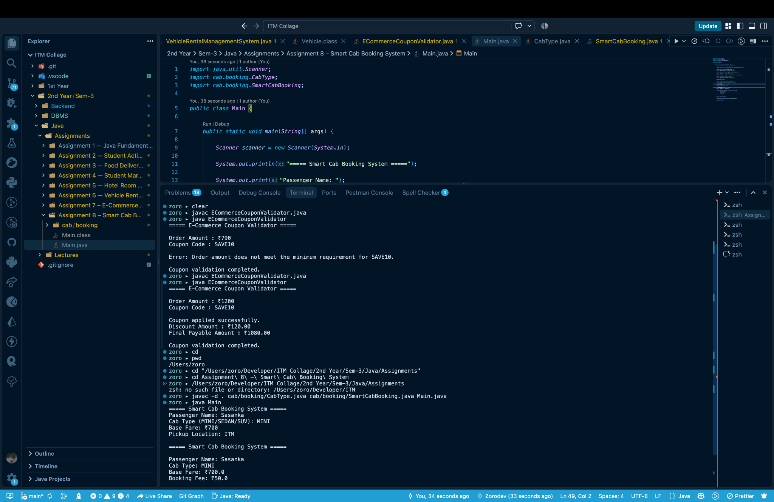
Figure 1: Smart Cab Booking System source code and execution.
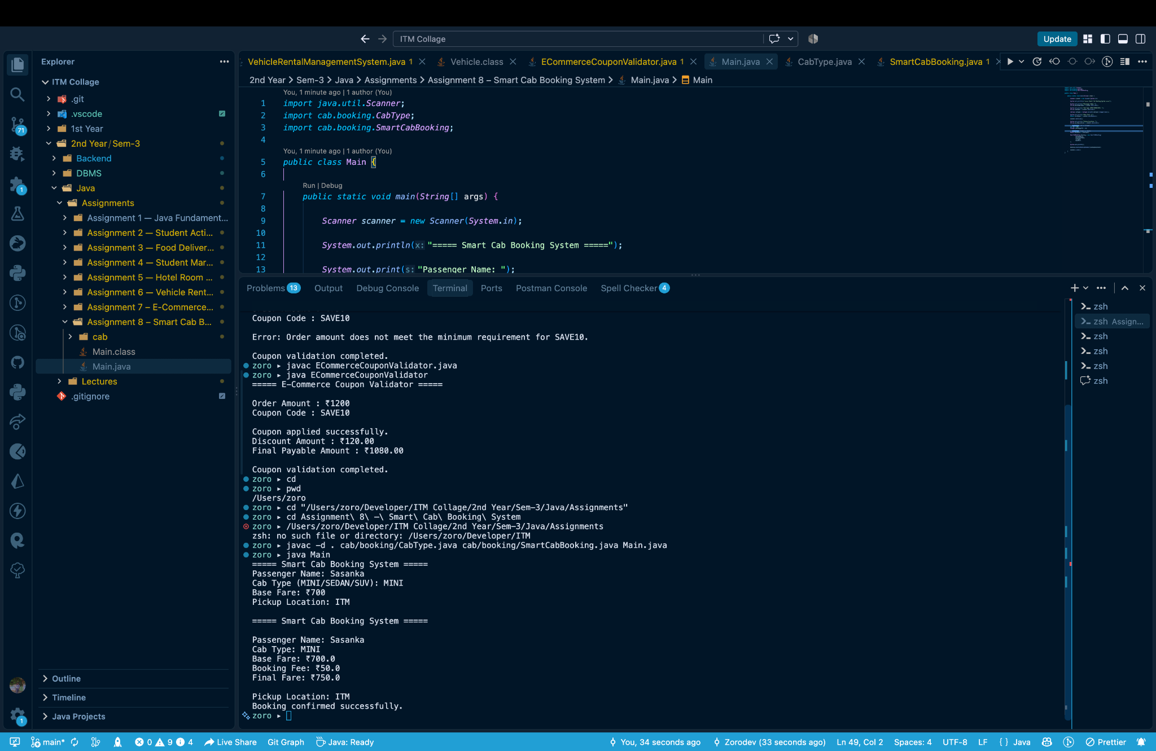
Figure 2: Successful booking output showing final fare and confirmation.

8. Output Analysis
For the test shown, the passenger is Sasanka and the selected cab type is MINI. The base fare is ₹700 and the fixed booking fee is ₹50. Therefore, the final fare is ₹750. The pickup location is ITM, and the anonymous Confirmation implementation displays the successful booking message.

9. Requirement Verification
Requirement | Status / Implementation
cab.booking package | Implemented for CabType and SmartCabBooking.
Import usage | Main imports both classes from cab.booking.
Wrapper classes | Integer and Double used.
Autoboxing / unboxing | Both demonstrated in Main and SmartCabBooking.
CabType enum | MINI, SEDAN, and SUV defined.
Final booking fee | bookingFee declared final and set to ₹50.
StringBuilder | Used to build booking summary.
Inner class | PickupLocation nested inside SmartCabBooking.
Anonymous class | Confirmation implemented anonymously.
Scanner | Used for passenger name, cab type, fare, and pickup location.
Correct final fare | Base fare + ₹50 booking fee.

10. Result
The Smart Cab Booking System was successfully implemented in Java. The program accepts user input, represents cab types with an enum, uses wrapper classes and autoboxing/unboxing, adds a fixed booking fee, builds a summary using StringBuilder, stores pickup information using an inner class, and confirms the booking through an anonymous class.

11. Conclusion
This assignment provided practical experience with packages and intermediate Java OOP features. The completed application demonstrates how packages organize code and how enums, wrapper classes, StringBuilder, inner classes, and anonymous classes can be combined to create a simple real-world booking application.

12. Submission Checklist
☑ User-defined cab.booking package created.
☑ Import statements used in Main.java.
☑ CabType enum contains MINI, SEDAN, and SUV.
☑ Integer and Double wrapper classes used.
☑ Autoboxing and unboxing demonstrated.
☑ Booking fee declared final.
☑ StringBuilder used for booking summary.
☑ PickupLocation inner class implemented.
☑ Anonymous class used for confirmation.
☑ Scanner used for user input.
☑ Successful execution screenshots included.

Student Name | Sasanka Sekhar Kundu
Programming Language | Java
Assignment | Assignment 8 – Smart Cab Booking System

